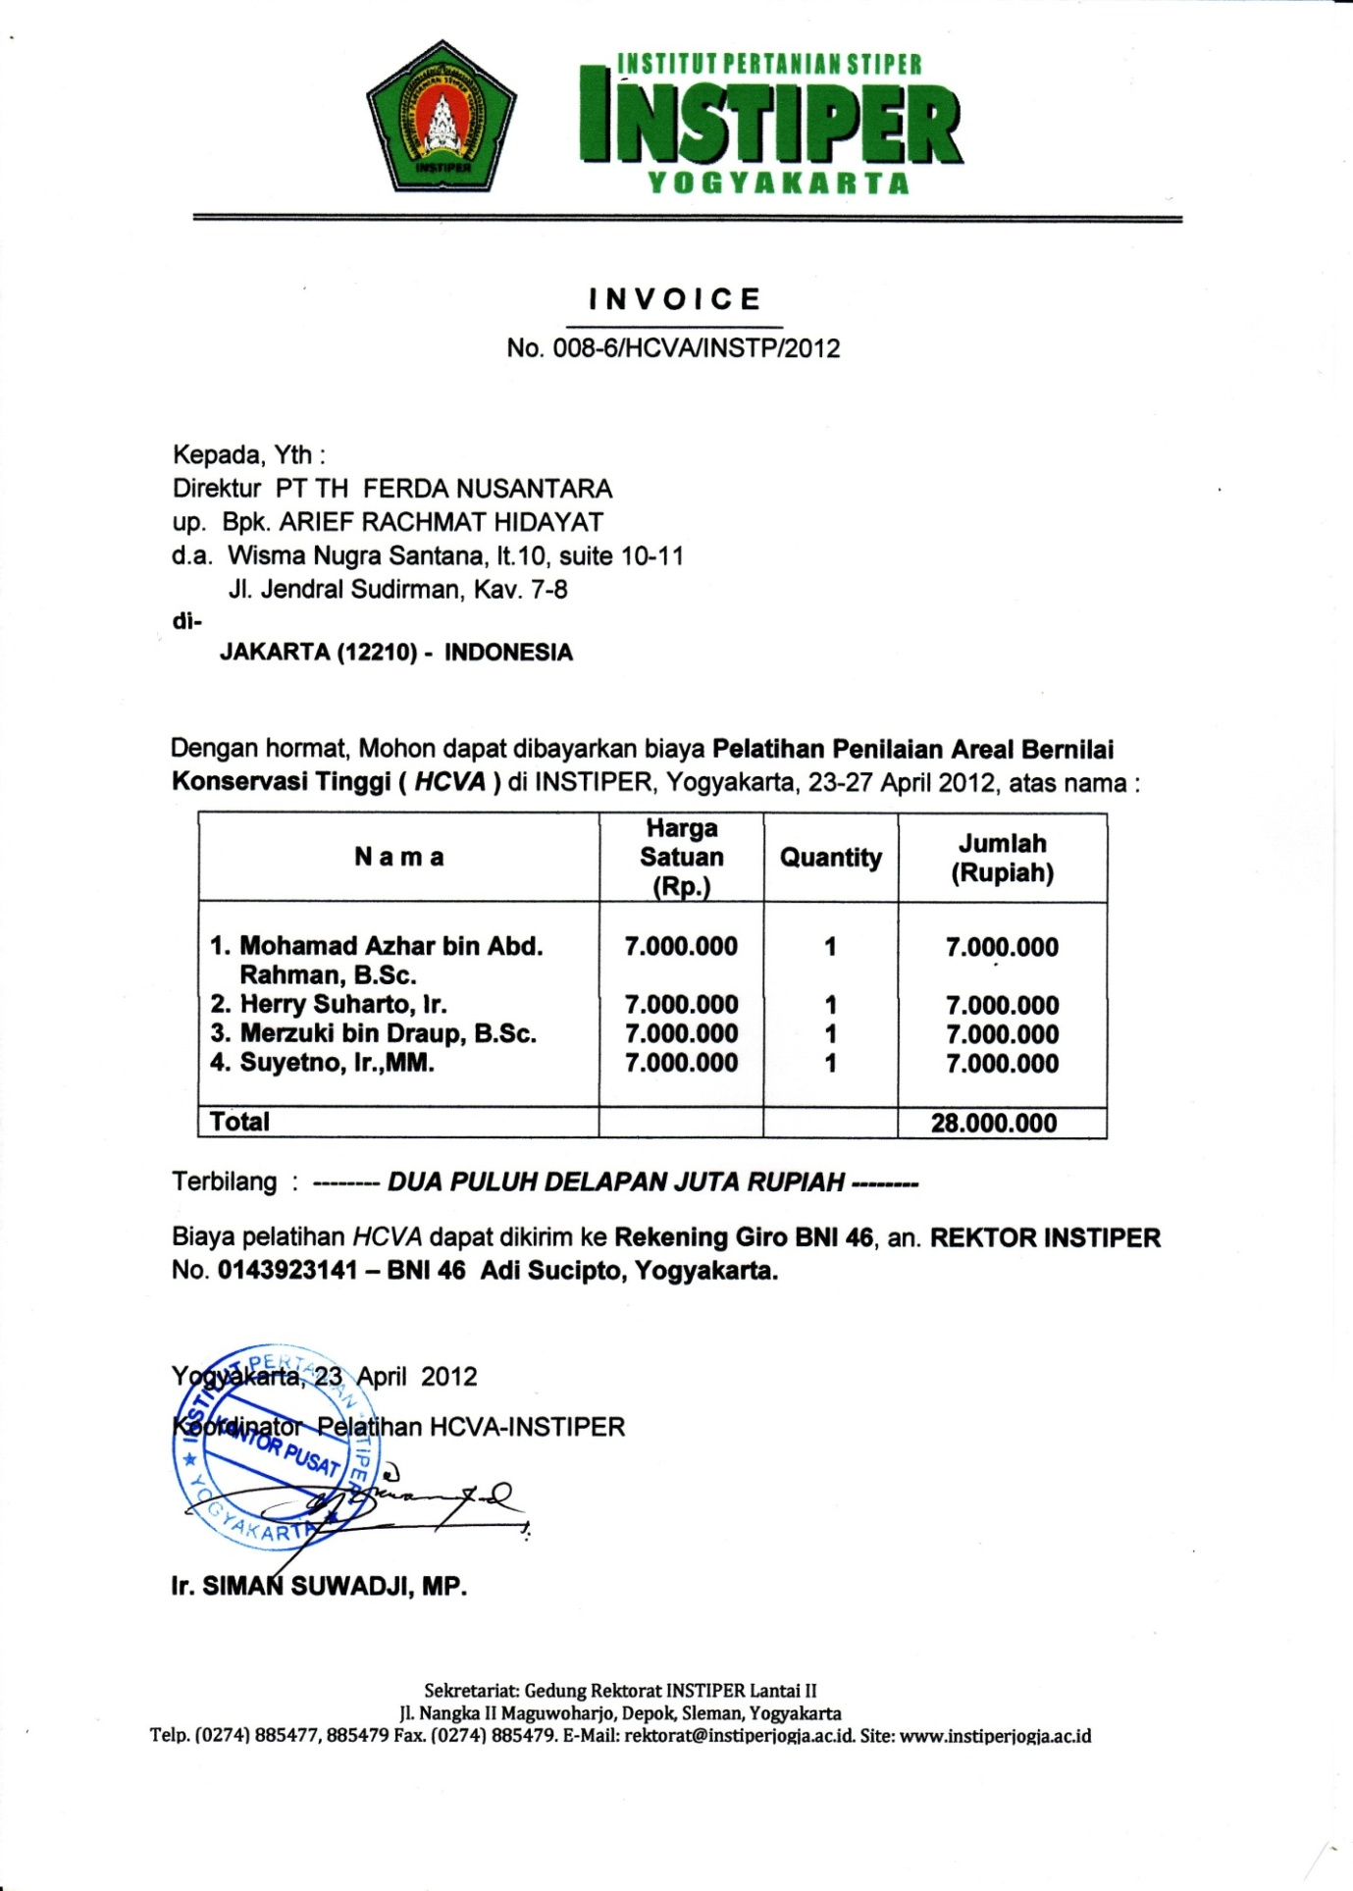

**UPT PERPUSTAKAAN**

|  |  |  |  |  |  |  |  |  |
| --- | --- | --- | --- | --- | --- | --- | --- | --- |
| **DAFTAR USULAN KEBUTUHAN BAHAN PUSTAKA** | | | | | | | | |
| Nama | | : | | | |  | | |
| No. Telp | | : | | | |  | | |
|  | | | | | | | | |
| A*) | Judul Buku/Non Buku (+Cet/Edisi) | | Pengarang/Editor | Penerbit | Tahun | | ISBN | Informasi Sumber  (alamat URL, toko, agen, dsb) |
| 1.  2.  3.  4.  5. |  | |  |  |  | |  |  |
| B*) | Judul Majalah/ Jurnal | | | Penerbit | | | ISSN | Informasi Sumber  (alamat, URL, toko, agen, dsb) |
| 1.  2.  3.  4.  5. |  | | |  | | |  |  |
| ***Catatan:***  *) Jenis Bahan Pustaka: A. Buku/ Prosiding; B. Jurnal   * Maksimal 5 judul untuk masing-masing jenis bahan pustaka * Cantumkan judul berdasarkan prioritas | | | | | | | | |

Yogyakarta, .........................................

(______________________________)